**Envision: Blueprint of Chinese Semiconductor Industry, Analysis of Intellectual and Financial Investment**

Ziyun Lu Yuxin Zhang

A Research Project Submitted for NYU Shanghai 2019 DURF Program

Abstract

As part of the ambitious “Made in China 2025” blueprint, Chinese officials have set the semiconductor industry a goal of reaching US$305 billion in output by 2030 and meeting 80% of domestic demand. Aimed high, the Chinese semiconductor industry seems frustrating as for its development despite the government’s support. As most commonly known, talents and capital resources are the fundamental drivers for the development of the tech-intensive industry. Guided by this concern, our research focuses on the two most important factors determining the prospect of this industry—intellectual training and financial investment. Our project aims to provide deep insights into the current bottlenecks and advise on future development to help achieve the long-term sustainable thriving of the Chinese semiconductor industry.

Keywords: Chinese semiconductor industry, talents, financing

Acknowledgement

First and foremost, we would like to thank our faculty advisor, Professor Guodong Chen, for his support and guidance through the entire summer of our research process. His insight into corporate finance and advice for research has been invaluable to our paper.

# Introduction

The semiconductor industry is fundamental for the construction of a high-tech and digitized society. For years, China has relied on the imported CPUs, GPUs, and AI chips for its Information Technology development. As we look at the global semiconductor industry, we see raw materials dominated by Japan, designing and manufacturing dominated by the US and Europe while China’s semiconductor industry seems inanimate. The has no apparent sign of surging considering the market share despite the repetitive urging from the government and waves of new companies aiming for breakthroughs. Although it’s hard to penetrate this market considering the oligopolist and capital-intensive market feature, it seems still confusing that there’s no dynamo in the Chinese market as funds and resources seem not being a problem for a government-pursuing target. Therefore, we want to look at things from the root and try to find the keys that might unlock the unanimity in the Chinese semiconductor industry. Specifically, we would like to focus on two things:

Firstly, we would like to evaluate the training of electronic engineering talents in China, since a sustainable, up-to-date training is the source for stable development in this industry. Secondly, we would like to look at the general feasibility of funding from non- governmental sources among semiconductor companies in China. We believe that although the government can provide funding at the beginning, for the long-term sustainable development in this industry, we need to thrive and compete within the private sector, as markets are usually considered as the filter for good and bad companies.

Our research direction is practical in the sense of its timeliness. As the Chinese government has set a very ambitious target for a complete, world-leading IC production chain by the year 2030, our research would give insight into feasibility in achieving those targets. Also, in comparing with the semiconductor industry features in the mature market, we might identify the deficiencies for further improvement, focusing on the fundamental development in education regarding electronic engineering, microelectronics, and the dynamics for the public sector fund-raising.

## 1.1 Difficulties and our solutions

## Chinese educational system is fundamentally different from that of any other country so that a direct comparison might be biased and unconvincing.

We previously would like to set up some quantifiable parameters from US semiconductor college education for comparison to discern what wasn’t doing appropriately with the Chinese semiconductor college education. However, when we really look into features of the talent development in Chinese and American educational system, this idea diminished quickly. The education of semiconductor talent does not only differ in how they distinguish the different track of talents by setting up different majors, but also in the educational period. During our research, we discovered many programs in US colleges especially targeting at fostering the IC designer talents, while Chinese universities set up courses more broadly. For example, students going for electronic information science and technology could go for chip designing, but also wireless communication and others related to signal processing and broadcasting. Moreover, a large portion of the employees in the US semiconductor industry hold bachelor’s degree, yet those in Chinese semiconductor industry has mostly minimum degree of masters. This observation mitigates the significance of the comparison between the employment rate at different degree.

To address these two problems, we decided that should do time-series research focusing on the only relevant Chinese data and study the trend of measurement such as the graduate-industry conversion rate, over the years to evaluate the Chinese educational system on its own.

The capital-raising situation in semiconductor industry are hard to capture.Contrary to the oligopoly situation in the US or in other parts of the world, Chinese semiconductor industry are featured by some big companies with waves of smaller and younger companies, which mostly receive the venture capital investment and are hard to track the investors and volume of capital. For this reason, we decided to focus on public companies whose financials are easier to acquire.

**1.2 Approaches and Method**

For the first part, we will give an overview on the Chinese semiconductor industry, including its constitution, features, and weaknesses. This includes the pattern of production applied by most firms; some key features regarding the technological and financing aspect of this industry, subdivision of the product and their features, and a discussion on the potential further developing direction.

For the second part, we will focus on evaluating the high-level (college-level) education regarding semiconductor. By focusing on the construction of three majors (Photoelectron Information & Science, Electronic Information Science and Technology, microelectronic). We would like to evaluate their talent fostering system from the following several perspectives:

1. Distribution of majors among Universities

2. Geographic feature of the major distribution

3. Evaluation of the Faculty resources for semiconductor-related majors in Chinese top universities

4. Evaluation of the employment situation among Chinese semiconductor-related majors.

The main purpose of these evaluations above are attempts to reveal whether the higher education are systematically transmitting qualified talents for the development of Chinese semiconductor industry. By analyzing from multiple perspectives such as faculty resources, the employment situation of related major, and the featured distribution of majors geographically, it might be possible to reveal the possible point for amendment as well.

The third part will be focused on the financing for the semiconductor companies, including an overview on current financing channels and an evaluation of the dynamics in the capital market for semiconductor companies. We will look into the following aspects:

1. Identified institutional investors and financial support led by the government

2. Balance Sheet analysis of selected publicly listed semiconductor companies and evaluation of credit market funding difficulties

3. Listing trend for semiconductor companies

4. Regression analysis— key financial figures that attract fund investments

# 2. An overview of the semiconductor industry chain

The semiconductor industry originates from the Silicon Valley during the 1950s and 1960s. Though the trend of its rising never stops, its development is dependent on the technological advancement and innovation on the application side, driving by different forces during different periods. So an overview about what semiconductor industry contains, what the market situation is like for it today, and what might be the next driver for it would fundamentally help the prelude of the discussion regarding the semiconductor industry in China, as it being the largest consumption market as well as a participant of this industry.

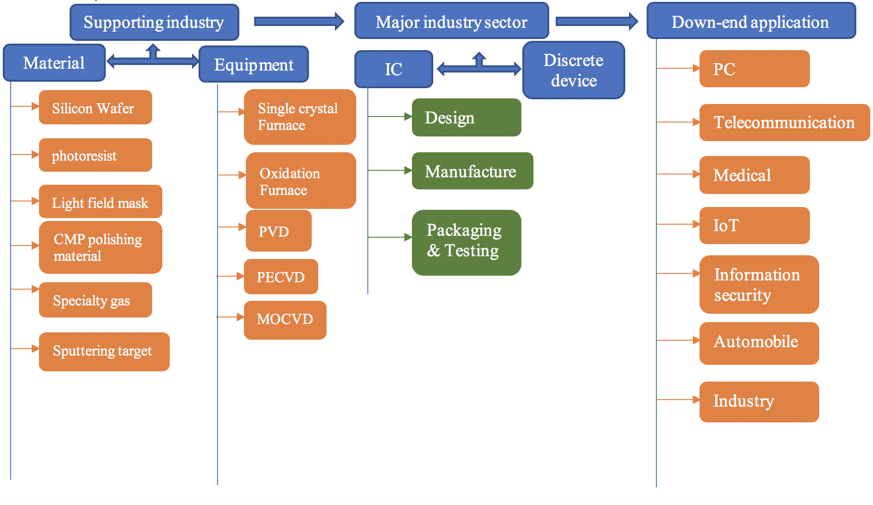**2.1 The product and value-added chain in semiconductor industry are finely labor divided**

**2.2 On the company side, two production patterns have formed**

Companies like Intel employ a typical vertical production mode (IDM) as they are fully involved with all segments along the vertical production chain, which includes designing, manufacturing, packaging & testing. A second type of companies employs a flat mode production (Fabless, Foundry, OSAT) and specializes in only one sector, doing either designing or manufacturing. TSMC is a typical company of this type that specializes in manufacturing chips. There are pros and cons for each production pattern. The vertical production mode has the advantage of manufacturing with lower yield, speeding up the production process while suffering from possible limitations from capacity and capital. The flat production mode has an advantage from its specialization and scaling while suffering from possible competitors. The trend internationally is that the production pattern is going more and more flat. This enables more participants in the semiconductor industry as the breakdown of the production chain. However, it makes the whole industry more competitive and those venerable easier to be expelled from the competition since the dominant power is harder to acquire.

**2.3 Division of sectors around the world has almost shaped all across the semiconductor industry product chain**

|  |  |  |  |  |
| --- | --- | --- | --- | --- |
| Industry chain position | Category | Name | Country | Companies |
| Upstream | Raw material | photoresist | Japan, US, China, Korea | FUSIFILM Electronic Materials，Everlight Chemical |
| Upstream | Raw material | Light Field Mask | Japan, US | Photronics, DNP, Toppean |
| Upstream | Raw material | Specialty gas | US, Germany, France, Japan | Air Products & Chemicals, The Linde Group, Air Liquide |
| Upstream | Equipment | Single crystal Furnace | Germany, US | PVA RePla Ag, Quantum Design |
| Upstream | Equipment | Oxidation Furnace | UK, China | Thermco,Centrothermthermal Solutions, Beijing NAURA Microelectronics Equipment |
| Upstream | Equipment | PECVD | US, Japan | Proto Flex,Tokki |
| Upstream | Equipment | Etching Machine | Dutch, Japan, US | ASML, Nikon, Canon, ABM |
| Midstream | IC | Manufacturing | US, Korea, Taiwan, Japan | Intel, Samsung, Tower Jazz, TSMC, Fujitsu |
| Midstream | IC | Packaging & Testing | US, Singapore, Korea, Taiwan | Amkor Technology, UTAC Group，Nepes, Unisem |

**2.4 Components of semiconductor industry are concentrated in Integrated Circuits**

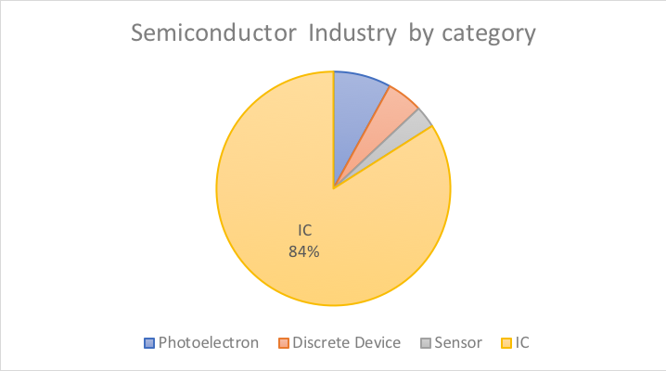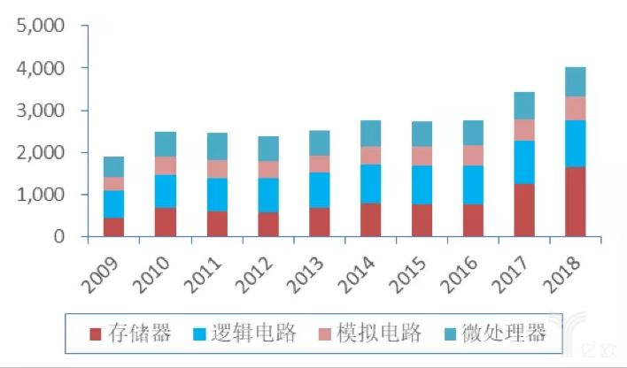According to the category, Semiconductors can be divided into Integrated Circuits (IC), Photoelectron, Sensors, Discrete Device. And the Integrated Circuits can be divided into digital Integrated Circuits and simulating Integrated Circuits, in which digital Integrated Circuits can be further divided into microprocessor, memory and logical circuits. From the statistics provided by WSTS, the IC dominants over 80% of the semiconductor industry, and the memory is the fastest growth subsector in the recent 10 years.

**2.5 Though slowing down, the industry is still having high momentum for the new drivers emerging from the application-end**

According to the prediction of the Gartner released in 2018 Q4, the international semiconductor industry is expected to grow at 2.5%, 8.1%, -1.8%, 3.8% for the following 2019 through 2021. With the slowing down on the PC side, an increasing demand has emerged from smartphone, automobile, IOT (Internet of Things) and server manufactures, which is changing the components of the driving forces. As data from IC Insights shows, the top two fields in the Integrated Circuits, which is a large portion of the midstream of the semiconductor industry are smart phone and PC (32%, 25%). With more applications of artificial intelligence, more computing power needed, demand for high-quality semiconductor chips is stimulated.

**2.6 Capital is intensively required in this industry and the value-add composition seems to be changing**

The semiconductor industry is a capital-intensive industry, and a very top-weighted industry, in which the companies top of the list have the most spending and dominant the rest of the list. Two representative Chinese semiconductor companies we choose in our research is SMIC and HiSilicon (Private), yet only SMIC releases its LTM R&D expense. From the chart we can see that being top 3 in China, SMIC’s total R&D spending is low compared to other world-leading semiconductor companies, while its R&D/Revenue ratio is around the middle level, which indicates that SMIC is dedicated to the fundamental capital-intensive research and aiming at continuously creating innovation breakthroughs.

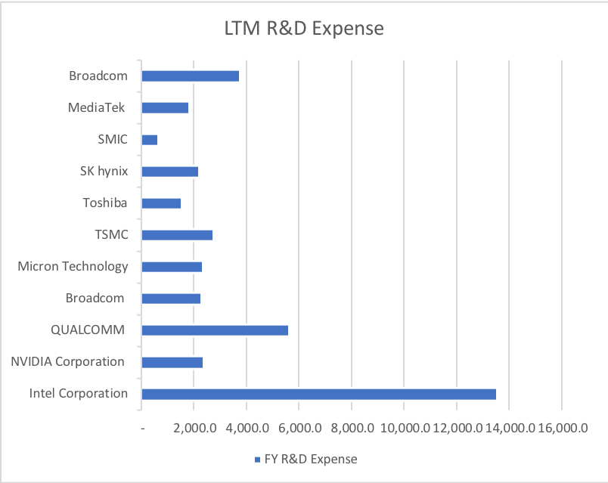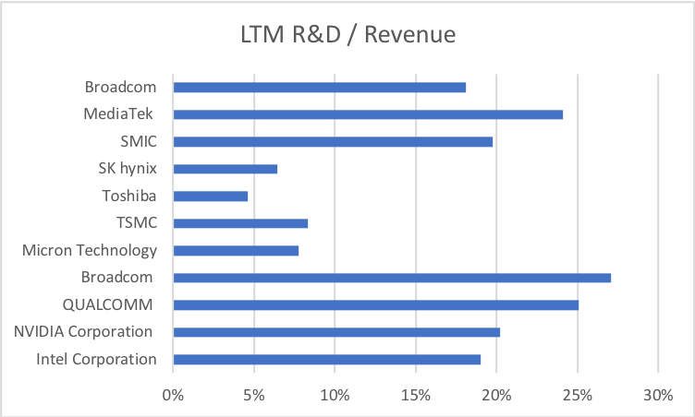

From the industry chain perspective, designing part used to be the highest in the value-added chain, yet in recent years, because of the trend of the flat production mode, specialization enables some cutting-edge OME companies to join the high value-added family. For example, data from the last twelve month shows that TSMC has an operating margin of 35.4%, and a net margin of 33.4%, which even exceeds that of Intel (with operating margin of 32.4% and net margin of 29.04%), which is a traditional vertical production mode company. (data until Jul-09-2018 from Capital IQ)

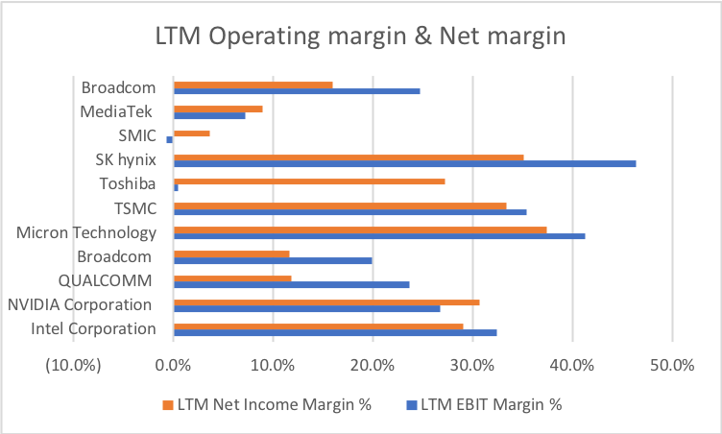

**2.7 Scale is essential for this industry for malleating Competition and raising margin**

A storm of merger and acquisition in the semiconductor industry is carrying on because of the rising competition due to the increasing number of competitors. For the Chip sector along because of the involvement of AI, IOT, more big technology companies such as Amazon, Google, Facebook, Apple, are introducing their own chips using their advantage and familiarity with the application-side industry, posing a large threat to the profitability of the old chip giants such as Intel. And the advancement of designing and manufacturing craft of the once weaker companies and the new-tech obstacle faced by giants are shrinking the technological discrepancies in all participants of the industry. These two forces pushed Giants such as Intel, Micron to seek faster ways of extending their customers and maintaining profit to keep the capital investment chain running.

Some famous Acquisitions are the Intel acquiring Altera in 2015, acquiring Mobileye in 2017, and Qualcomm acquiring NXP in 2016.

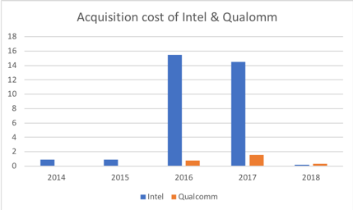

(Source: Intel 10K & Qualcomm 10K)

# 3. Development of Chinese Semiconductor industry

As the second largest consumer of semiconductor products, China is longing for developing a complete self-supporting production chain yet is still admittedly much behind, especially in the high value-added part in the production chain. Looking separately from the production chain, we see that on the upstream as for the facilities, China is highly dependent on importing from US companies to support itself. And as for materials, some such as the target material is of equal level compared with the advancing ones, yet others like the photoresist still have much room for improvement before complete localization. Looking at the midstream, China is doing great in packaging & testing, yet in the high-end manufacturing and designing, China is much behind and much less comprehensive in product categories. For example, the high-end processors, FPGA, has nearly zero self-supporting ratio.

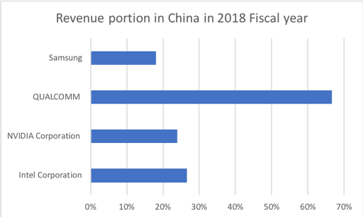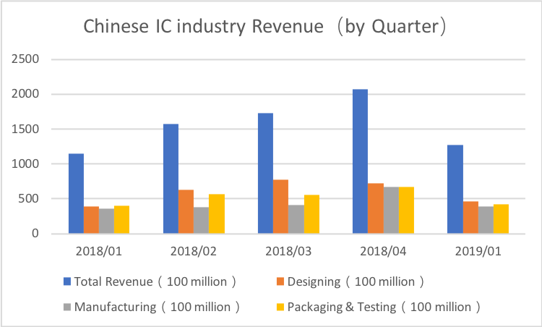(Source: Samsung, Qualcomm, Nvidia, Intel 10-k) (Source: CSIA)

Looking at the regional revenue of some world leading Semiconductor firms, we can see a large of them captured in the Chinese market. On the one hand, this indicates that the Chinese chips still have much room for improvement on technology advancement. On the other hand, this suggests that Chinese semiconductor companies have a huge potential market to grab, as long as they catch up with the current leaders.

Though large potential and opportunities are present for Chinese semiconductor firms for catching up and grab, this domestic industry is in reality struggling. Looking at the revenue data merely from IC sector, we see no obvious driving force of surging. In fact, because of the trading tension between China and the US, the IC manufacturing, packaging & testing are in shock. To understand why the semiconductor industry in China, especially the IC sector is so vulnerable, it would be helpful to dig into the current stage of development for Chinese semiconductor industry, spot the weakness and thus targeting at resolving them from multiple approaches.

**3.1 Mobile processors are catching up while high-end CPUs are hard to compete due to lack of technology as well as supporting ecosystem**

With the rise of HiSilicon, China is becoming competitive in the mobile-end processors internationally. However, on the CPU, especially the high-end CPU sector, Intel, AMD have completed dominant power. This partly is due to their powerful chip performance. However, a greater reason, as we believe, is due to the lack of supporting ecosystem. After all, the semiconductor industry is a demand-driven industry. Old participants in this field such as Intel, with its 50 years of development, has created a business-end reliance from building an ecosystem with supporting chip products, architectures, software, locking its business partners inside of it. Considering from this point, China has a long way to go as for taking a bite in the high-end CPU business market as it requires tech breakthroughs, intelligent business designs and lots of capital support to compete in this market.

It’s even more obvious from the company side to see how important the ecosystem-building as such great influence on the survival of firms. By our research, the comparatively large Chinese semiconductor firms have basically two categories. One is to do OEM on large-scale. An example of this case is SMIC. Another is to also cover the product on the down-end side such as mobile phones and PCs. An example of this case if HiSilicon. The mobile phone produced by HUAWEI is the ecosystem HiSilicon builds to consume its HiSilicon chips.

**3.2 Memories are dominated by Korean, Japanese, and US companies such as Samsung, Hynix and Micron.**

There are two kinds of memories, DRAM and NAND. And currently China is falling behind from almost all possible aspects in this sector. The patents are fewer than competitors, the yield are much less than competitors, the cost are higher than competitors. It would be a continuously growing frustrating situation if no technological breakthroughs are attained.

**3.3 Technologies are much weaker in the high-end general-applicable chips such as FPGA, AD/DA**

As more participants enter the competition and more new technology are expected to be applied in chips, more types of chips are demanded. At the very start of this industry, there is only CPU, which is designed for doing the general computing task such as the matrix computing. Now, with the AI, IoT, smart cars and more applicable situation being discussed, more chips are made specially to perform certain tasks or have flexibility in performance at different scenarios. For example, the GPU, also known as the graphic card, is designed to perform the graphic computing. For example, FPGA, also known as Field Programmable Gata Array, is designed to provide flexibility for the function of certain chips.

Because of the weakness in basic chips sector and lack of supporting ecosystem, the advancement into the high-end and more subdivided chip sectors are not just impossible, but unwise. Though markets are lost because of this, it’s better to start from the basics and by accumulation of experience, to catch up and surpass eventually.

**3.4 On the OEM side, low-end companies are competitive while high-end manufacturing craft not penetrated yet**

If we concentrate our focus and look at the IC manufacturing sector along, we find some common features about Chinese IC manufacturing companies. In our research, we used the top two IC manufacturing companies in China by its market value. They are SMIC, Huahong Semiconductor and their main business is mostly to manufacture based on other companies’ design. According to our industrial-wide research, the most value-added part in the semiconductor industry production chain is the designing part, of which the net margin is around 30%. And among the OEM companies, the sector leader, which is TSMC, has net margin around 33.4% as well, but this high margin is only attained by their mature and scalable production chain industry-leading craft techniques, such as the 7nn manufacturing craft. To get an idea of how SMIC, Huahong stand on their peers (OEM companies), we give a look at their net margin for the financial year of 2018.

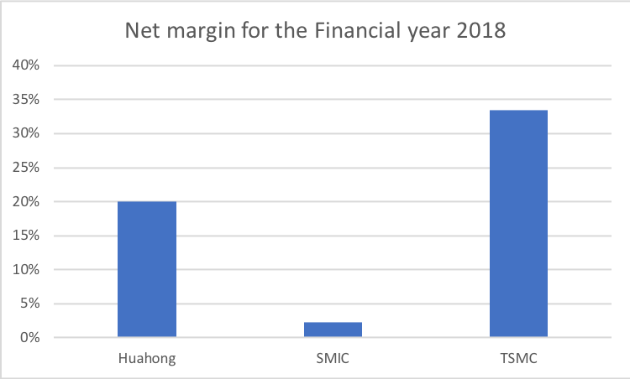

(Source: Huahong 10-K, SMIC 10-K, TSMC 10-K)

It’s obvious from the numbers that Chinese OEM firms obtains little margin from their business because of the low-end techniques in manufacturing only chips above 22nm.

# 4. Intellectual investment in Chinese semiconductor industry

As a high-tech intensive industry, the development of Chinese semiconductor industry requires consistent flow of high-quality semiconductor talents being created by the educational system, especially from the high-end education institutions – Universities. To evaluate the university system of such talents, we decided to look at the following aspects of semiconductor education in colleges.

**4.1 the related major set-up in Chinese universities**

As for the major set-up in universities, we specifically dig into those highly related to the semiconductor talent development, which are Photoelectron Information & Science, Electronic Information Science and Technology, and Microelectronic. We crowned data from a database containing major information from all Chinese universities. And the data we are mostly interested in are from the following perspectives: School, Major, School Quality, Major Quality, Location.

The quality of universities in China are generally measured by two standard – Whether it is credited with the title of “985” and whether it is credited with the title of “211”, which are two projects in China officially rating the quality of university education. Project “985” contains in total 39 top universities in China, and project “211” contains 112 universities in China. And all “985” universities are also “211” universities.

Major Quality is measured by whether this major is rated as “important major” in this universities. As it is usually the case, important majors are usually put on more talent and capital resources and are thus of better quality. Besides, the location of those universities and the possible concentration pattern of equal university might reveal some information of the regional clustering of semiconductor industry or the unequal emphasis different provincial leaders put on semiconductor industry development.

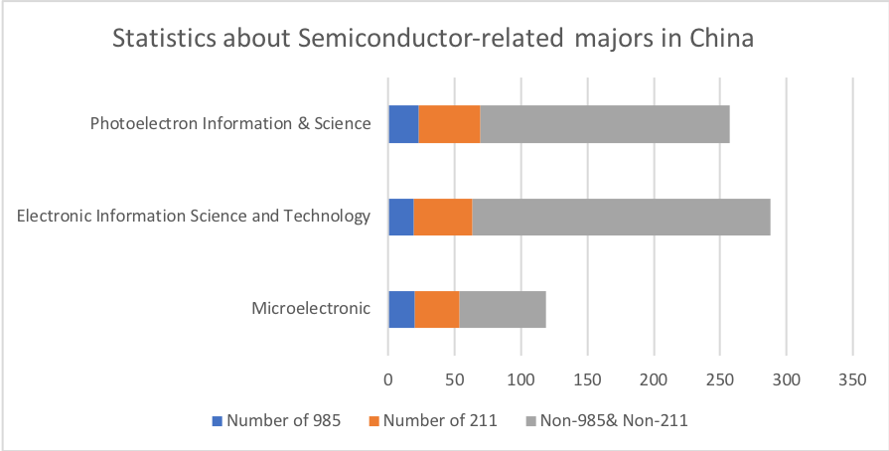

(data as of Jul-09-2019)

Considering the in total 820 universities (not including the authorized independent academies), the Electronic Information Science and Technology is the most prevalently offered semiconductor-related major in Chinese Universities. This is largely due to its generality feature. The least popular one microelectronic major is much less prevalent for several reasons, largely due to its shorter period of establishment. To give an insight into how those universities are distributed across China, we statistically process the data we have above and count them by province.

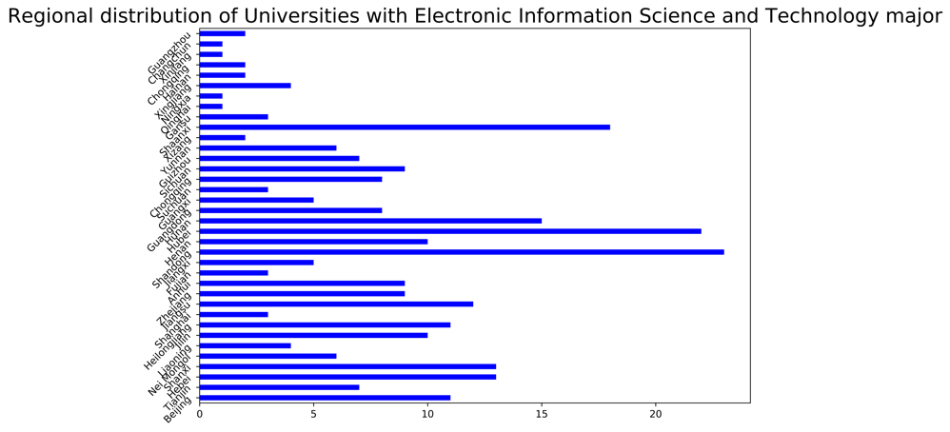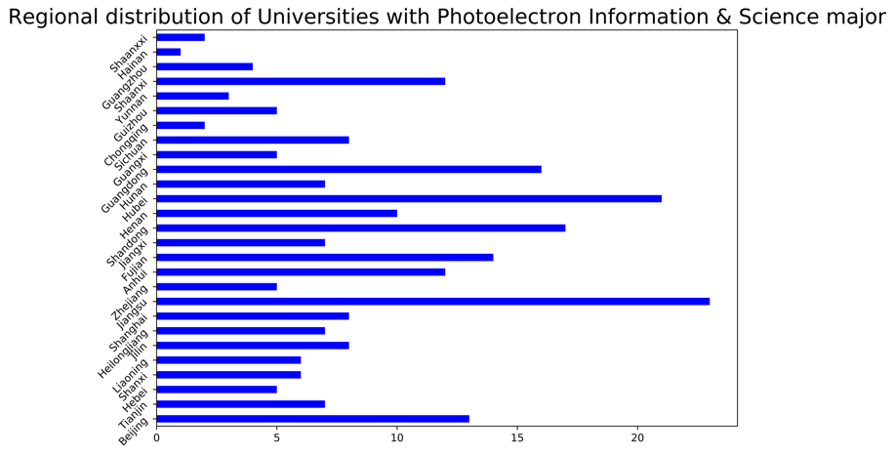

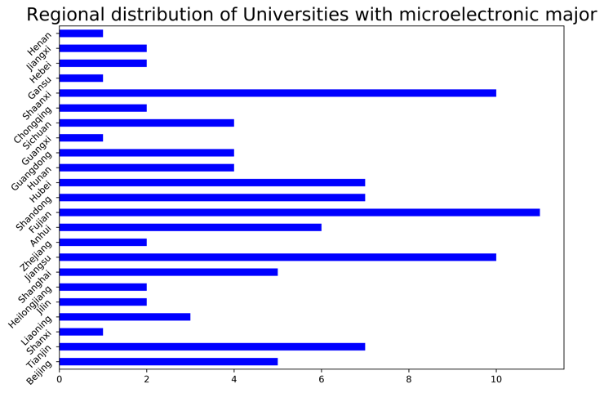

Although seemingly divergent majors, their university density distribution has similar patterns. If we only consider the top three provinces in the rank of number of universities opening certain major. We have Hubei, Jiangsu, Guangdong for Photoelectron information & Science major; Hubei, Shandong, Shaanxi for Electronic Information Science and Technology; Fujian, Shaanxi, Jiangsu for microelectronics. The reason of such concentration pattern in Universities offering semiconductor-related majors are complex yet are generally linked to the educational & economic resources, the industrial practical resources, commercials and transportations. For example, Shandong, Jiangsu, Fujian, Guangdong, a large portion among the top several offering related majors, are all distributed along the coastal area, where there are more semiconductor industry doing business internationally.

To get a closer look at how the major distributions are related to the economic regionality feature in China, we statistically plot the number of universities offering such majors in the east, middle, and western part of China.

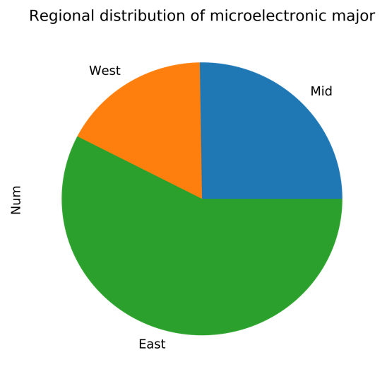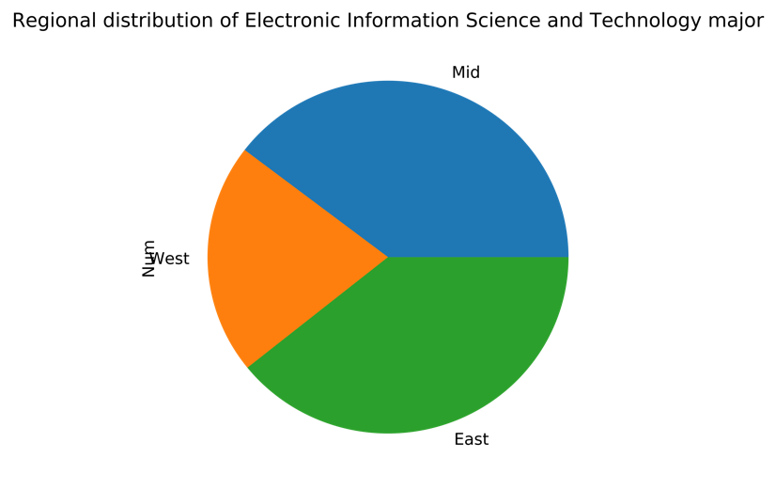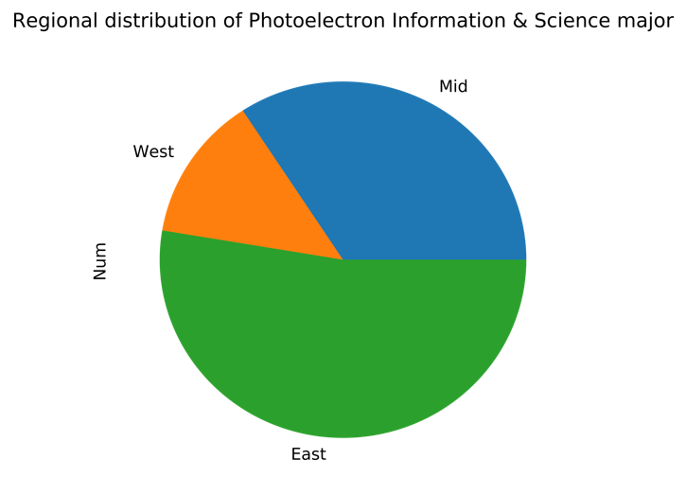

From the plot, we can clearly see that the east part of China, including the capital Beijing and the financial center Shanghai, have the most universities offering semiconductor-related courses, which might explain why tech talents are most populated in the eastern coast of China, helping creating dynamic business opportunities, thus attracting more talents and creating a positive cycle of talent, business and education.

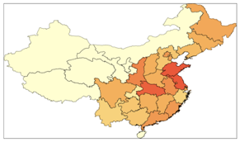

Combining all three majors and look at the semiconductor-related major development as a whole, we want to not only focus on whether a university offer such major, but also measure to some extent how well such majors are constructed in those universities.

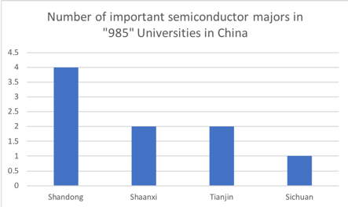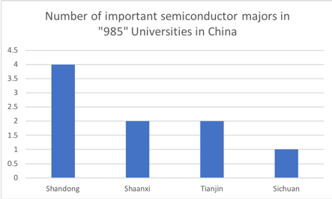

It seems from the statistics that not many top universities are putting much concentration on developing semiconductor-related majors, with most such universities located in Shaanxi, Sichuan and eastern coastal areas (Jiangsu, Tianjin, Shandong). But this does not imply that those majors are developing poorly in Chinese Universities, to further look at how well they are developed, we must scrutinize into it and in our research, we focus on two major weighing features: the faculty quality and the employment situation of those majors since after all, talents need to be productive either in the research or industrial field to add value to the semiconductor industry.

In conducting searches on these two aspects, we decided to filter the universities we have at hand and choose “985” level universities to take a look at first, as they seem to have the most resources and talents to develop those majors well. There are in total 33 “985” universities with such majors offering.

**4.2 Faculty resource evaluation in Chinese University regarding semiconductor majors**

From the perspective of the faculty resources, we evaluate their industrial experience by counting the number of patents applied and proved by the national patent bureau.

From the previous industrial-wide research, we made it clear that the semiconductor industry is a talent-intensive and application capacity intensive field thus the college should have offered opportunities for its students inside of the course system to have rich industrial-side intern experience to have them prepared for graduation and career. But if we would like to evaluate the quality of faculties, it’s only plausible to investigate their technique-application ability by looking at the patents that they have created in their teaching experience. This is because the common measurement for the college faculty resources, such as the number of SCIs they’ve published can hardly be applied as they only reflect the research ability, which is not what the semiconductor industry value most. However, the path of getting a patent is the process of converting knowledge into practice, which is what’s best we can find as a measurement for the applicability of faculty resources.

To measure this, we would like to know the number of semiconductor-related patents all colleges across China have applied over the years. But the public patent database provided by cnki.net only provides a maximum attainment of 6000 for one user. To avoid biases caused by the random subgroup selection, we decided to rank the data by year and attain full datasets for the most recent years. Based on this principle, we gather full data from 2017 until August 11, 2019, amounting to 5929 datasets. We would like to focus on the two features in the sampling dataset. Firstly, we would like to look at the general trend of the number of patents applied in each year from 2017 to 2019. Secondly, we would like to focus especially on the ratio of the number of patents applied by universities to that in total so as to observe whether the education-to-industry transformation educational structure has been improved by semiconductor-related majors in universities. This also indicates the applicability of faculties employed by universities as they are the major participants of patent applicant.

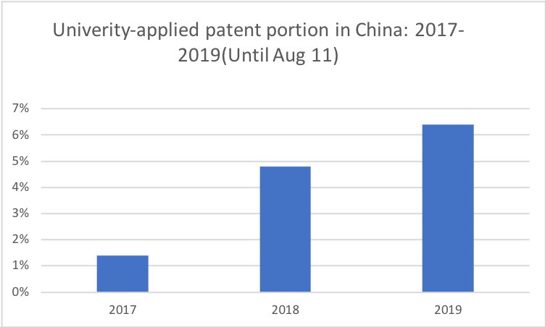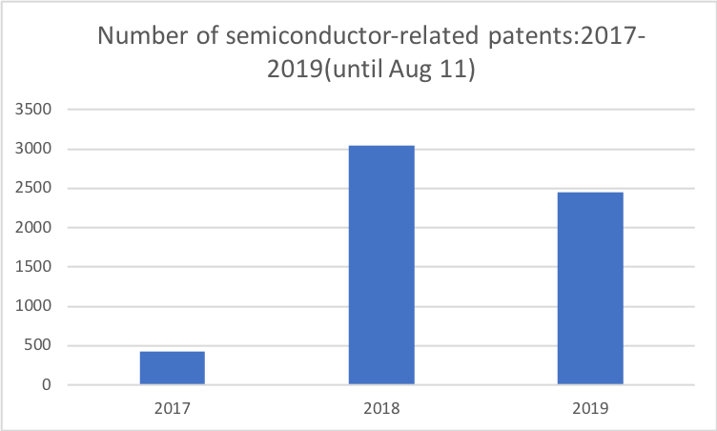

From the 5929 samples that fully attained from semiconductor patent database from 2017 to 2019, we see a surge in the published patent from 2017 to 2018. It’s noticeable that we are using the data for the release of the patent, of which the application date would be one or two years earlier than this. This means that the surge for the patent application happens around 2015 to 2016, right after the publication of the government document “Made in China 2025”. The drop in the published patent from 2018 to 2019 is resulted from the lack of full recording of information in year 2019 since the published data is updated only until August 11, the date at which we pull data from the database. Getting a full estimation of the whole year published number of patents using the same time proportion, we can still estimate an increase in the number of semiconductor-related patents from 2018 to 2019.

The next step is to investigate how the applicability of the universities have as a relative number of the total. This is proposed for the fear that even if the number of patents applied by colleges rise over the year, if that number as a portion of the total number of patents applied that year, it still indicates the decrease in the quality of college education as for those majors. From the sample we collected, the ratio of the patents applied by universities from 2017 to 2019 has a rapid increase in between the years, increasing at a steady speed. With the consideration of a relatively calm market and industry development from 2017 to 2019 in semiconductor industry, this suggests that the development and application ability of universities as for their faculty and students are rising in general, which is a good sign for the advancement of the semiconductor-related majors.

This could be due to several reasons, one of which being the course systems becoming more and more mature and improvised, compared to the very beginning. The second reason could be of universities extending more cooperation with local semiconductor companies to smooth the transition from school to industry for students. A third reason could be that universities started focusing more on the recruitment of application-style talents instead of focusing on research capacity for those majors discussed.

**4.3 The Employment evaluation of Chinese University regarding semiconductor majors**

The employment of the graduates and their choice of career path of further education is a reflection of how well the university education, have trained them for jobs. We are especially interested in how well the college training has prepared students for the suited jobs(major-matched). According to the released 2018 data from Zhaopin.com, which is a recruitment website, the job-suited rate for the general electronic information majors are around 30.88%, which wasn’t low compared to some majors such as bioengineering (13.56%) but is comparatively low compared to accounting-related majors (64.17%).

This number (30.88%) is achieved by universities giving out questionnaires for all their graduates regarding how much they think their jobs are related to their majors. But the measurement for this somewhat subjective and vague since only three choices “very related” “somewhat related” “not related at all” are given. Though we might question the precision of the statistics, this number can still reveal the low industrial talent conversion ratio in Chinese universities concerning the three majors under discussion.

We would like to further investigate into the employment situation at the perspective of the employment ratio at undergraduate level. For this purpose, we selected all “985” universities with these three majors as our study data set. We pull the related data from their released Employment Quality Report for the year of 2018. Of the filtered 33 “985” universities who set those three majors, we would only able to pull out the relevant actual employment rate (excluding those going for graduate school) from 23 of them (2 universities didn’t release the Employment Quality Report and 8 didn’t offer the employment rate containing those going for further study). From the statistics we can see the average actual employment ratio after bachelor graduation for semiconductor-related majors is only 42.1%, with Tsinghua University ranking the lowest at 5.9%. This reveals that the bachelor’s degree education for semiconductor talents aren’t proven enough for going into career directly for most students pursuing those majors. Considering the industrial-application feature of the relevant jobs, we doubt that this is due to the course set-ups among those majors and the lack of adequate faculty resources.

A recent new released by the CSIA has it that among the 8 million graduates of semiconductor-related majors, from bachelor’s degree to PHD degree, only 30 thousand eventually get into and contribute to the development of this industry, which is strikingly only 0.375%. However, we might be biased as for only blaming the educational system in China as the demand side power also involves in the employment situation in the semiconductor industry. Therefore, we would like to investigate the employment situation for university graduates from the demand-supply perspective. Specifically, from the supply side, we would like to see the trend of regarding number of graduates transmitted by universities and those employed by industry. To investigate the graduation-employment situation all across time can give a direct idea of how the universities are doing in improvising their educational system and how the universities graduates are accepted by the market. From the demand side, we would like to investigate the attractiveness of the semiconductor-related jobs, focusing especially on the salary attractiveness. And by comparing to the relative pecuniary attractiveness of semiconductor-related jobs and other jobs, it’s possible to give insight into the future of this industry from the demand side.

**4.3.1From the supply side, has the college education made its students qualified for the semiconductor industry**.

The majors are broadly set, and students can easily be converted to other more attractive or easier-entering business. With this consideration, we would like to see the trend of employment/graduation for semiconductor-related majors from the time-series perspective. This employment/graduation ratio shift according to time measures industrial conversion rate for the semiconductor related major education, and can somewhat reveal the advancement of college education of these majors after central government issued a detailed documentation “Made in China 2025”, which sets detailed deadline and target for the independency of Chinese semiconductor industrial chain.

To understand the employment situation of the semiconductor industry, we decided to use data from the top public listed companies in China according to their capitalization, we selected 42 of them based on the situation in 2019. From their employment construction structure, we selected the number of Technician Employees, as we consider it most relevant to the majors under study. We used their sum by year as an indicator for the whole industry’s total employment volume. And as we track it annually, we would be able to see the trend of market expansion and rise in talent demand.

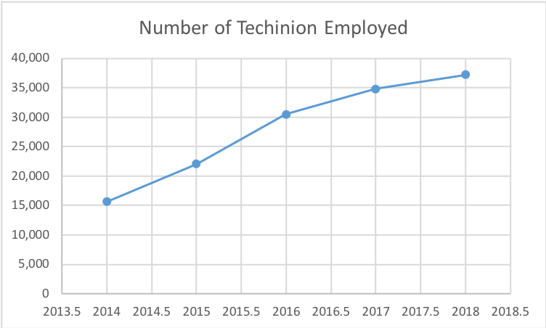

Dividing by the critical year of 2015, we see a relatively steady increase in employment as revealed by Technician employment for the selected 42 public companies. But this trend seems to be slowing down in recent years. It could be because of the saturation of the industry or because of the inadequacy from the college training. Yet as we discussed about the large whole in the industry demand, it would be more probable that this situation is due to the efficiency in university training.

But to further determine whether the university training has the tendency of improving after 2015, since the central government’s document urges colleges to enforce the talent development in universities, we also need the data from number of college graduates from 2014-2019 regarding those relevant majors. But to address the consistency problem as for majors considered here, we decide to look especially at the top 5 universities with microelectronics major since this is the major most targeted at semiconductor industry & IC. The five Universities in our sample are Tsinghua University, Peking University, University of Electronic Science and Technology of China, Xidian University and Dongnan University. They are chosen as our sample for the following two reasons. They all have microelectronic majors open from 2014 -2018, which makes graduation data available all through our chosen five years. And they are the top 5 universities considering this major, so that their graduation data trend could be considered as representative of the whole university education of semiconductor-related majors.

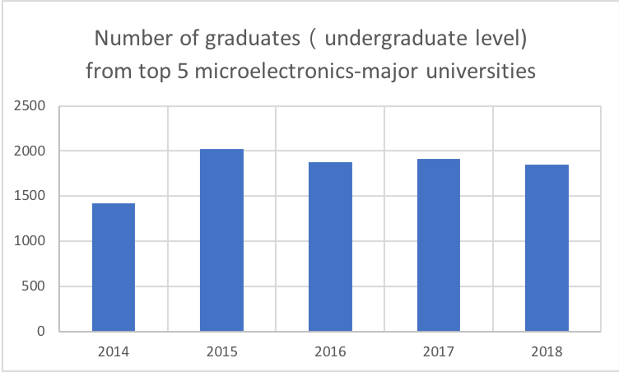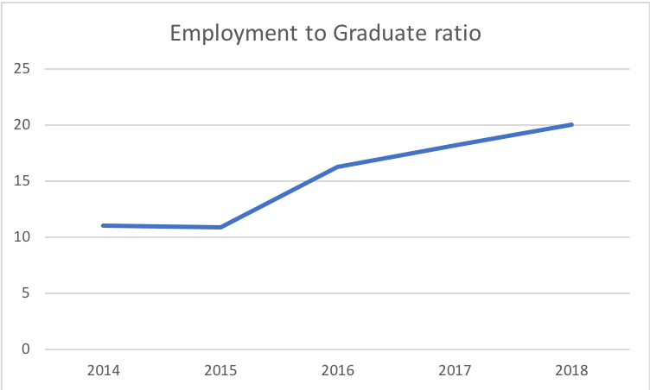

The first graph is an illustration of the total number of graduates from microelectronics majors from the sampled 5 universities. The number of graduations seems to be static and even has the sign of decline, which could be due to the more selective and focused feature of such education urged by the central government. And when we look at the Employment to Graduation ratio, we could see an obvious increase from the critical year of 2015. This is a good sign for the related-major education as it indicates the periodical triumph the universities achieved in developing a more industrial-oriented education for semiconductor talent development after the demand from the central government.

**4.3.2 The treatment for semiconductor talents in the industry**

A look into the demand side might be good to start at the salary condition, as it being one of the most important attractions for talents.

As mentioned above, the low talent conversion rate from university education to the industrial talents can be partially attributed to the immature educational system. Yet from the other side, it might be because of the low attraction of jobs in this industry. To further evaluate this, we would like to look at the salary for the semiconductor-related jobs offered by companies in this industry, as salary being the most direct measurement for how attractive a jo might be.

For this purpose, we decided to use 51job website as a data source. We crowed 901 raw data by putting “semiconductor” as a key word for job searching, and after we filtered the null data and those related to sales and administration, we got 358 usable data for jobs most related to the “chip designing”, “chip manufacturing” “semiconductor facility manufacturing”. Then we plot the histogram for the salary distributions for the data set selected.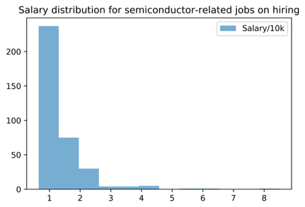

If calculating the average salary, we get an average salary of 13.76k RMB. But because of the right skewness of this salary distribution, the high-paying jobs are super rarely offered and the most jobs have a salary around 10k RMB per month. According to a report released by 51job officially at the third quarter 2018, the average salary for the financial industry is about 10.389k with very small skewness. This might suggest that the salary attraction for semiconductor-related industry was less attractive considering the fact that it is more intelligent-intensive than other jobs.

But to further determine whether this talent attractiveness issue has improvised after the publication of the “Made in China 2025”, we need to investigate the trend of attractiveness of semiconductor industry after the critical year of 2015. Meanwhile, we would also manage to investigate where the lost trained talents for semiconductor-related majors eventually go for employment. Since the relevant majors such as Photoelectron Information & Science, are usually taught broadly and thus can convert to industries such as IT, we would like to look at the relative attractiveness semiconductor industry has against the IT industry after 2015. For the simplicity of data attainment, we would like to focus on the IC sector within the semiconductor industry as it being the most technical and of major component. And for the IT industry, we specifically refer to those involving information transmission, computer software services, as defined by the National Bureau of Statistics of China. And we use the salary level as a measurement for the attractiveness of an industry.

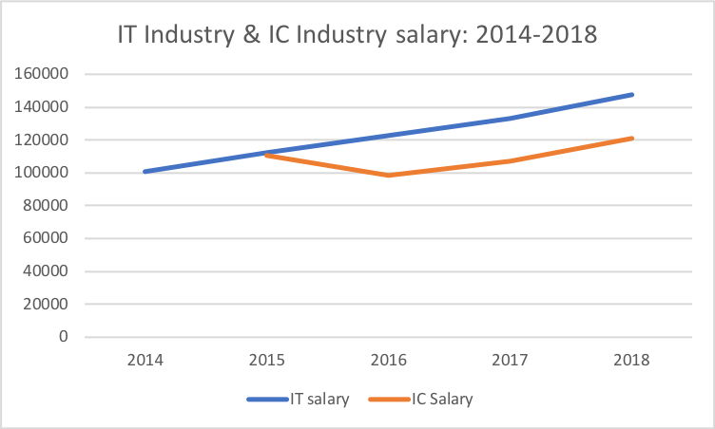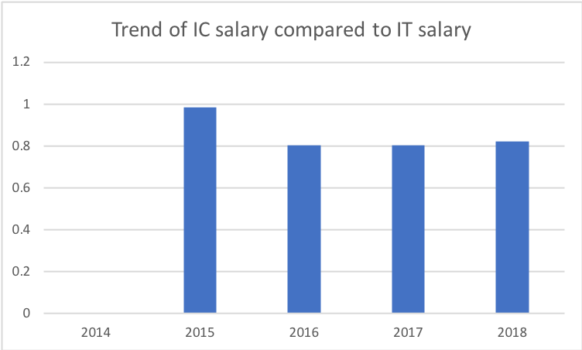

(Data Source: National Bureau of Statistics of China)

It’s surprising to actually observe a decline in the salary level for IC industry after 2015. And due to such decline, the salary ratio of IC industry to that of IT industry declines and stabilized after 2015, creating a disadvantage for IC companies to recruit suitable talents. This devastating fact reflects several things both regarding the industry and the college education of relevant talents. Firstly, the universities didn’t really equip their semiconductor-related major graduates with competitive advantages on the job market. Secondly, the industry isn’t financially doing well as the salary offer is relatively low. Considering the semiconductor industry as being intelligence intensive, we fear such poor graduate-industry transmission might turn into a vicious cycle which would contaminate the development of the whole Chinese semiconductor industry.

**4.3.3 Industry conversion ratio for university graduates is on the rise: Demand-driven or Supply-driven?**

In 4.3.1, we discussed the employment and graduate situation for semiconductor talents from 2014 to 2018, in which we see a rise in Technion employees in publicly-traded semiconductor companies, a decline in the number of university graduates from the “985” universities in China. Combining these two features, we also see the trend of a rising conversion ratio from university graduates to industry talents. However, such a rise could be driven by both the demand side and the supply side of the semiconductor talent market. On the supply side, there is a university, of which the improving education quality can better equip the students with adequate capacities in fitting into the industrial careers. On the demand side, there are the semiconductor companies. Their improving attractiveness such as salary level, working environment can also contribute to the number of talents seeking a job in the semiconductor industry. So we would like to figure out which is the dominant power in the rising industry talent conversion ratio.

In 4.3.2, we evaluated the change in the attractiveness of semiconductor industry, focusing on the IC sector especially. To adjust for the effect of rising salary levels across times, we measure the relative attractiveness of IC industry as compared to the IT industry, as talents of which are considered as the most convertible in between. By looking at the results achieved in section 3.3.2, we can see a drop in relative attractiveness from 2015 to 2016, followed by a static trend ever since, which indicates little of the demand-side factor in contributing to the rising industry conversion ratio.

Looking at the other side, which is the supply side, we see in section 3.2 that the application capacity, measured by the proportion of university-applied semiconductor-related patents, is on the rise. As we think that the relevant jobs are intensively application required, we see a strong indication that the rising conversion ratio of the industry talents are the result of the improvised university education, which is the supply side driven factor.

However, as we screen further into the time-series shifts in the university graduate, we are somewhat confused that despite the lack of industrial talents in Chinese semiconductor industry, the number of graduate students each year from the top “985” universities focusing on the semiconductor majors are on the decrease. According to our analysis, there might be two reasons helping to explain this decline in graduates. The first is totally market employment driven. As the universities sees the low industry conversion ratio in previous years among their graduates, they are forced to shrink the size of conversion as in China, the employment ratio matters among universities as being a measurement for the quality of the university education, which is related to the national fund and the quality of student resources they can attract. The second is more strategic and may come from the change in the semiconductor-major education mechanism, which is proposed in the central government document “Made in China 2025”. If being this reason, then the reduction of the graduate may indicate that universities are revolutionizing the semiconductor major education, towards more targeted, more elite-focused, to produce more well-trained graduates. Considering the result, we attained in 4.2, there is an autonomous reflection and revolution in the educational system regarding the semiconductor majors around the critical year of 2015, we would like to consider this shift in industrial conversion rate a mixed result of the market power initiated by universities. Seeing the previous failure in employment situation among graduates and worried about their own image, the universities started exploring a more market-oriented way to improvise their semiconductor major education and further equipped students with more application capacity.

# 5. Financial Investment in Chinese semiconductor industry

**5.1 Composition of identified investors**

Among the identified institutional investors in Chinese semiconductor industry, state-owned investment vehicles such as National Integrated Circuit Industry Investment Fund and China Investment Corporation are the largest players in this capital market.

National Integrated Circuit Industry Investment Fund: Launched in 2014, the National Integrated Circuit Industry Investment Fund Phase 1 raised 138.72 billion yuan from 16 institutional shareholders. The phase 1 fund completed its investment and the phase 2 fund, expected to raise 150-200 billion yuan, is under preparation to provide further financial support for the industry, and especially for IC designers. According to the statistics of the phase 1 fund distribution, 67% went into IC manufacturers, 17% were pocketed by IC designers, and 10 % for IC encapsulation and test providers and 6% for equipment and material producers. Various investment types include public and non-public equity investment, funding mergers and acquisitions and direct investment in companies’ subsidiary funds, among which 23 are public investments, 29 are non-public investments, and the total number of effective investment projects is about 70.

These state-owned investment vehicles, aligned with the government’s policy objectives, mainly focus on creating national champions—a small set of leaders in each critical segment of the semiconductor industry (including design, manufacturing, tools, and assembly and test) and a few provinces in which there is the potential to develop industry clusters. Additionally, the Chinese government has actively pursued consolidation to spur the creation of national champions. For instance, Tsinghua Unigroup, a state-owned enterprise, bought two of the top four Chinese fabless companies—in 2013, it acquired Spreadtrum for $1.7 billion and RDA Microelectronics for $0.9 billion—and aimed to combine them into a single entity.

A number of factors could possibly make semiconductor companies relatively unattractive to institutional investors as PE and VC funds. Uncertainties of R&D conversions are high in this industry. Investors have to wait for a long gestation period before substantial returns. Additionally, the ongoing trade tensions and disputes over Huawei add another question mark to the future prosperity of Chinese semiconductor industry. The Trump administration blacklisted Huawei in May and announced significant relaxation on Huawei’s ban in June. These significant movements roiled the stock market, where Wind’s semiconductor industry index (882121) had a daily volatility of 2.13% and an annualized volatility of 33.58% for the period from January to July in 2019. In the middle of trade disputes, the semiconductor index (882121) experienced a drawdown of 15.84% within only five trading days between April 25th and May 6th. Such uncertainties make it even harder for semiconductor companies to raise capital in the public market.

**5.2 Balance Sheet analysis: relatively low debt to asset ratio shows the difficulties with funding through credit market**

As revealed in the earlier parts, the Chinese semiconductor industry is composed mainly by small and medium companies. However, companies of these sizes are confronted with huge challenges with financing in the credit market. In China’s credit market, China's four state-owned commercial banks are in a dominant position in terms of asset size and local branches. Due to structural reasons, the majority of their commercial loans are issued to state-owned enterprises. It is much more difficult for companies of small or medium size to receive financial support from commercial banks. Nearly all banks have unanimously withdrawn from the small-scale loan business. With the complexity of procedures being the same, it inevitably increases the costs of loans for small and medium companies on a relative basis. Additionally, from the risk management perspective of commercial banks, issuing loans to such companies increases their monitoring costs compared to large, state-owned enterprises. To achieve the same return, banks have to make loans to a number of companies, hiring more staff to monitor the loans and undertake higher risks. These have all made commercial banks less motivated to lend to small and mid cap companies.

This could also be verified by the industry’s average and median debt to asset ratio. From our observation of a selection of 40 leading public semiconductor companies, the average debt to asset ratio published in their last fiscal year’s financial reports is 34.05%, and the median is 32.30%. However, according to data published by Research Institute of Listed Companies, the median of debt to asset ratio of publicly listed companies in China, excluding financial companies was 41.51% for the fiscal year of 2018. From the statistics, we could also observe that companies that ranked top on the size of debt were mainly state-owned giant enterprises. This also echoed banks’ incentives to make loans, favoring large cap and state-owned corporations against small and medium companies, which therefore leading to the difficulties that semiconductor companies face when raising capital from the credit market.

**4.3 Semiconductor industry company listing trend**

As of Jul 28, 2019, there are a total number of 109 publicly listed companies under the semiconductor industry category on Wind terminal. The following chart shows the year when these 109 companies listed and the market in which they are listed on. This excludes companies that was previously publicly listed but delisted or acquired; in other words, this only shows the listing trend of companies that are currently listed on the main board, SME board, ChiNext (Second Board), National Equities Exchange and Quotations (NEEQ), and the newly launched STAR market.

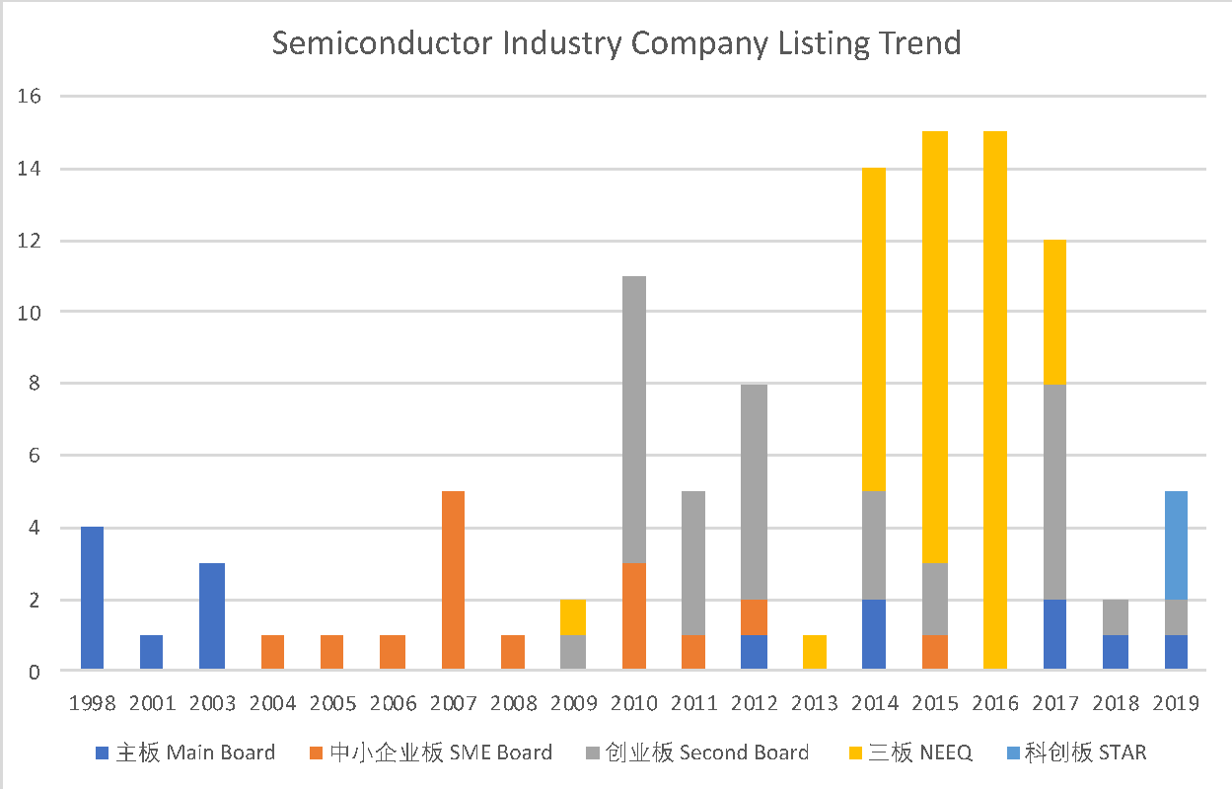

(Data Source: Wind, as of Jul 28, 2019)

In general, there is a clear trend for companies to be listed in accordance with favorable market conditions and policy support. The SME Board was launched in 2004, ChiNext was launched in 2009, NEEQ was reformed at the end of 2013, and the STAR market was launched in 2019. Each of these events was followed with new semiconductor IPOs, whose number also positively responds to such favorable policies and market conditions.

A substantial growth could be observed in the number of companies listed on NEEQ from 2014 to 2016. NEEQ, reformed at the end of 2013, now serves as an over-the-counter platform for equity transfer and trading, especially for small and medium companies. It is intended to provide companies with direct (direct investment) or indirect (increased equity pledge value) financing functions. Different from the main board, NEEQ implements a registration system instead of the approval system; in other words, once the company satisfies the requirements, it can be directly listed on the NEEQ market. Therefore, NEEQ opens up a new financing channel for small and medium semiconductor firms, which excels in procedure and speed.

The following table shows the number of semiconductor companies that are currently listed on each market and its proportion. For the newly launched STAR market, among the 25 debuting companies, 3 of them belong to the semiconductor industry, and there are more expected to be listed in the coming days. In addition, more than 20 companies that were previously listed on NEEQ, was delisted after raising a certain amount of capital in 2018-2019, being acquired or preparing for an IPO on the main board or the STAR market.

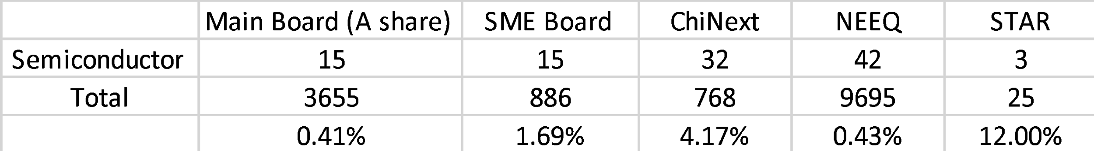

(Data Source: Wind, as of Jul 28, 2019)

**4.4 Regression analysis: percentage of stock shares held by investment funds as a function of company’s market capitalization**

Considering that the timing of each investment is different and the information which investors weigh on can be much more than what’s on the company’s financial statement. Our regression may not be able to reveal the exact rationale behind each investment but tries to find statistically significant causal relationship between the percentage of stock shares held by investment funds and the companies’ financial figures. It intends to answer the question statistically: what the factors are for a semiconductor company to attract fund investment in its stock shares.

The input for Y is a series of fund holding ratio, which is the percentage of stock shares held by investment funds for 60 semiconductor companies listed on the main board, reported on the companies’ 2018 financial statement. We tried to regress the Y on indicators of size, growth, profitability, R&D capability and capital structure, such as revenue, revenue 5-year CAGR, net income, R&D expense, ROIC, ROE, number of technicians, number of staff, and debt to asset ratio. Among all trails, size indicator, the reciprocal of market capitalization proved to be the only statistically significant factor in the OLS regression. The following table shows the results of the regression.

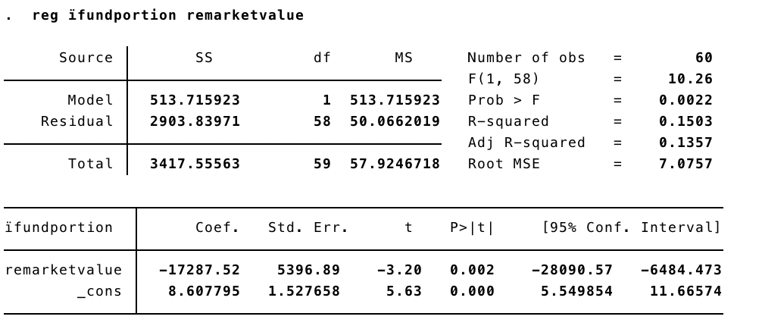(Screenshot from STATA, Data Source: Wind)

The x-variable is the reciprocal of the yuan value in millions of a company’s total market capitalization as of Dec. 31st, 2018. The t-stat for this variable is -3.20 and the p-value is 0.0022, which shows the statistical significance. Then, we tested whether there existed omitted variables in this regression model. The result from Ramsey RESET test shows the model has no omitted variables.

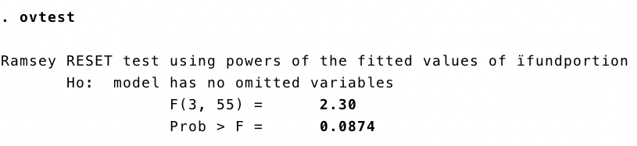

Further, we checked the exogeneity of the model and the distribution of residuals with the following scatter plot, which shows that the residuals have zero conditional mean.

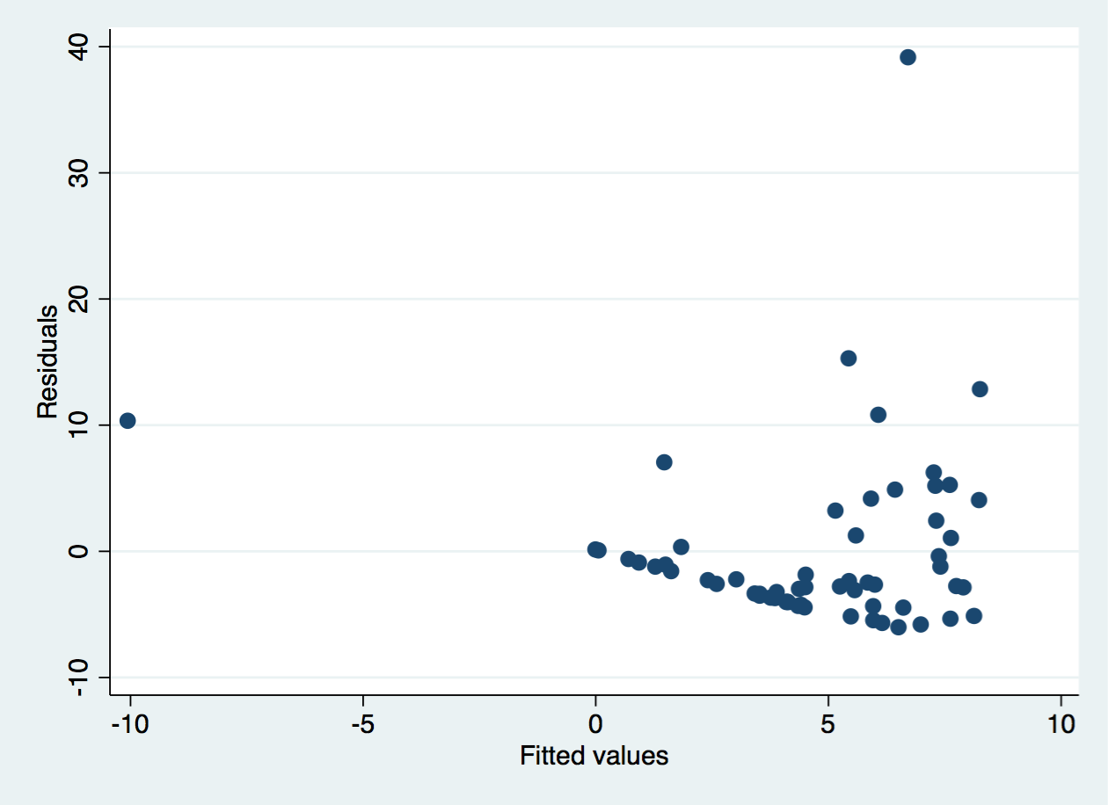

However, from the scatterplot of residuals against fitted values, we detected that the model suffers from heteroscedasticity, where the residual variance is correlated with the independent variable. Therefore, we have to use robust standard errors to obtain unbiased standard errors of OLS coefficients under heteroscedasticity, where the results are shown as follows.

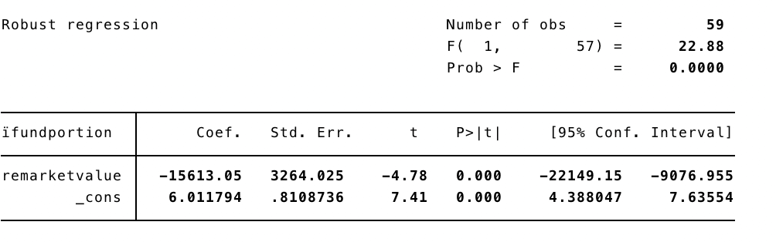

The variable remains significant after adjustments, where the t-stat is equal to -4.78 and the p-value is smaller than 0.05. From the regression results, the coefficient for this variable is -15613.05, which means that if this reciprocal decrease by 1 percent, the percentage of stock shares held by funds is going to increase by 15613 percent. In other words, if the market capitalization of a company increases, the percentage of its stock shares held by investment funds should also increase correspondingly.

Large companies are preferred by investment funds over small and medium companies in the semiconductor industry. This finding is also consistent with our previous discussions on state-owned investment vehicles dedicatedly supporting big national champions. There could be two possible explanations for larger company to be favored in the semiconductor industry. One is economies of scale and the other is about R&D capability. A larger company may have a more versatile research team. Considering the high fixed costs for R&D in this industry, a large company is able to extend the research further than what the budget of a small company allows. Small and medium companies may still face difficulties in attracting fund investments for financing.

**6. Conclusive discussion & Future prospect**

With a high target set to attain industry-wide independence in semiconductor industry, China is still very much behind the world-leading semiconductor countries in all perspectives -- designing, manufacturing, material-processing, facility-providing. Seeing those inadequacies with the Chinese semiconductor companies, our research focus on the more fundamental, and more micro part influencing the long-term development of Chinese semiconductor industry -- the supply of adequate semiconductor industry talent, and a well-established financing system in supporting the rise of the semiconductor companies in China. The following are our findings, upon which we would like to expand a little discussion about our opinion of them.

**6.1 Majors are generally set up broadly but with trend of being more focused**

Three majors under our research regarding the semiconductor industry are Photoelectron Information & Science, Electronic Information Science and Technology, Microelectronic. They are selected by looking at and matching the development target described in the admission information. Qualitatively speaking, other than microelectronic, the two other related majors, Photoelectron Information & Science, Electronic Information Science have rather broad and general talent cultivation plans and direction regarding the future career after graduation. For example, people would take those majors can easily transfer to the IT industry or the information communication industry.

However, in recent years, with more universities started developing majors at more focused directions, number of universities opening microelectronic majors starts increasing. But as we discovered, the absolute number of universities opening up this major is still rather small (a little over 100), led by the top (“985”,”211”) universities. The lack of focused elite faculty resources and restricted industrial-side connections are posing obstacles for smaller, less elite universities in setting up such major. So it is projected by us that no explosive increase in the number of focused, good-quality semiconductor education is expected in the short run in China.

**6.2 Majors display geographic density discrepancies and present industrial oriented features.**

Counting number of universities opening semiconductor majors by province, we can see a large discrepancy presented in all three majors. The coastal and eastern part of China dominates all majors regarding the number of universities offering them. And Guangzhou, Shaanxi, Jiangsu, where most high-tech, semiconductor companies locate, and where economics most prosperous, has the greatest number of universities offering such majors. This indicates that the semiconductor-related major is a rather employment-oriented field of study, which requires industrial experience.

This reveals a clear feature in the Chinese semiconductor industry that the education and the industry goes hand in hand, which further stressed the importance of relevant major construction in Chinese high-level educational system. on the other hand, it’s also revealed that the cooperation with the industry is also vital for the development of relevant major development.

**6.3 The exercise of combination of industry and teaching is still weak in Chinese universities but has trend of improvising in recent years**

As acknowledged in our previous research findings, the semiconductor major education are highly intensive in its training of applicability, which is usually down through incorporating industrial intern into the course system. That is to say, the level at which major courses are set up to equip students with application capability measures to some extent the education quality of those universities. And in our research, we find that the general level of university applicability in semiconductor-related fields is weak, as measured by the proportion of university-applied relevant patents. However, looking at the trend from 2017 to 2019, we see a conspicuous rise in this proportion, indicating that the universities in China are doing more contributions than before on developing the application capacity of their graduates, preparing them to better fit into the industrial side future career.

**6.4 An increase in the industrial conversion rate is detected for university graduates, and it is due to the increased education quality in universities, as revealed by our research.**

By taking graduate data from “985” universities in China, and measuring market employment by the number in top 42 listed Chinese semiconductor firms, we could see an increase in the employee/graduate ratio, which measures the industrial conversion rate for talents. To figure out whether the demand side or the supply side help explain this increasing trend, we took a separate evaluation on the two sides. On the supply side, we see from the patent data that the education quality did rise. On the demand side, we use the salary level for the semiconductor industry as a measurement for the attractiveness of relevant jobs. By tracking the salary level across time, we tried to match the trend with that revealed in the conversion rate pattern. With care, we further evaluated the relative salary level of semiconductor related jobs to that of the IT industry across time as talents are most convertible in between them. Yet we find no change and even a decrease in the relative attractiveness in the semiconductor industry, which rule out the demand side explanatory factor in contributing to the increase in the industrial conversion rate.

**6.5 The industry’s financing depends highly on government support and company listing accords closely with the introduction of stock market policies.**

State-owned investment vehicles, aligned with government objectives, provides the most capital funding for the semiconductor industry. These efforts are largely devoted to creating and supporting companies that are in leading positions in this industry. Difficulties with funding through the credit market are revealed by comparison between the semiconductor industry’s debt to asset ratio and that for other industries. Current policies on commercial loans adopted by major banks are not conducive to an industry that is dominated by small and medium companies. In addition, by plotting the time and the board in which semiconductor companies were listed, a clear trend can be observed that the listing events are in close accordance with favorable market conditions and policy support.

**6.6 A company’s market capitalization proves to be the only statistically significant factor for the percentage of its stock shares held by investment funds.**

We regressed the percentage of stock shares held by investment funds for 60 listed semiconductor companies on the reciprocal of the company’s market capitalization. The x-variable is statistically significant with p-value smaller than 0.05 and the regression model has no omitted variable. The residuals have zero conditional mean and are normally distributed around zero. Though the original OLS regression model is subject to heteroscedasticity, the x-variable remains statistically significant after using robust standard errors to adjust. Our regression analysis reveals that fund investors prefer large cap companies in the semiconductor industry, where they hold a larger percentage of stock shares than in smaller-cap companies. Small and medium semiconductor companies may still face difficulties in attracting fund investments for financing.

# 7. Future Improvement

**7..1 Only data from “985” universities are used in studying the number of graduates in semiconductor majors each year and it would be better to construct a full image of the graduate situation in all Chinese universities.**

The reason for us only selecting 33 “985” universities to study the time-series shift in the number of graduates from semiconductor majors is that they are a selected group of universities that have stable openness to those majors. However, selection bias may still exist since we only study the best universities and use them as a reflection of the overall university education.

**7.2 Data set for our regression analysis might be too small, which only incorporates company’s 2018 financial figures available on the Wind Terminal.**

We only find one statistically significant factor, market capitalization, for the percentage of stock shares held by investment funds. This can result from our data set being too small for the fact that there are only a total number of 60 publicly listed semiconductor companies. Only for these 60 companies, a quantitative measure for fund holding is available. Another limitation is that the regressors in our model are financial figures reported on company’s 2018 annual report. Other factors such as growth and ROIC may take a longer time to be reflected in fund investors’ decisions. Therefore, these factors that fund investors may weigh on didn’t prove their statistical significance as causal factors for fund holding ratio.

References

“Made in China 2025”

Patent Database: <http://epub.cnki.net/kns/brief/result.aspx?dbPrefix=SCPD_FM>

University Database: <https://gkcx.eol.cn/>